1979 UK 450SL Rear Sub-frame Removal

Having looked at the Mercedes workshop manual and the Haynes manual, I decided to proceed with this job. Neither of these manuals provide a complete guide for the job, so I created this document to aid anyone trying this procedure. I went through a fair bit of trail and error to come up with the best procedure, so ignore any background inconsistencies in the pictures.
As far as I can tell, there are two different sub-frames used on R107 SLs and another different type on the SLC. Depending on which sub-frame use have, you may, or may not need to remove the prop shaft to simplify the job.
Details of the three sub-frame types is shown here;
https://www.sls-hh-shop.de/main/de/mercedes-280-560sl-w107/35-hinterachse/35-d-differenzial-und-antriebswellen
The first task is to remove the middle and back section of the exhaust. Newer cars have a shorter mid section, for those, only the rear section of the exhaust needs to be removed.
Lift the car as appropriate, I use a scissor lift.
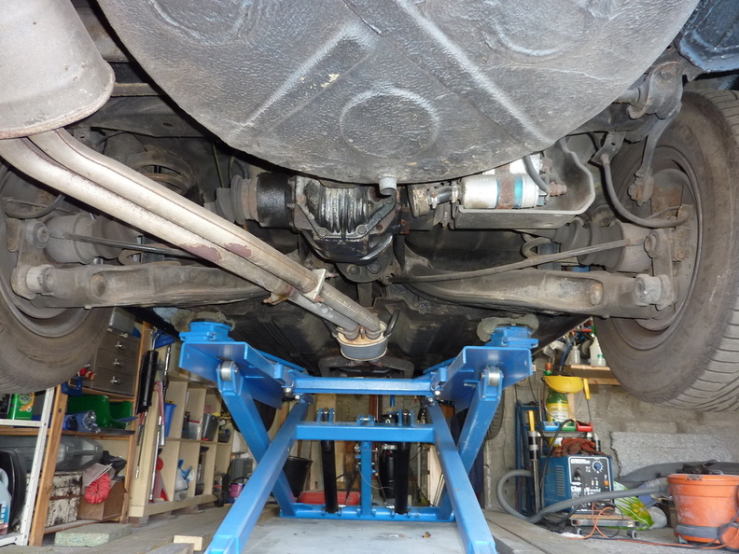
Remove the exhaust clamps from the mid and rear exhaust sections.
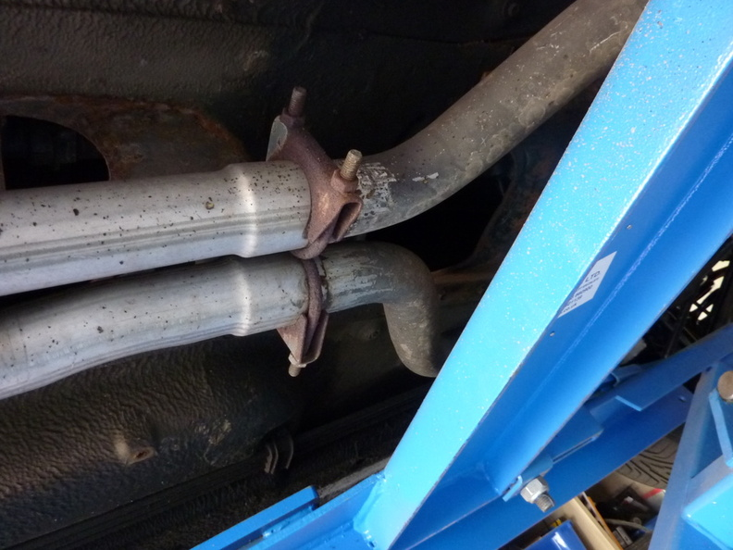
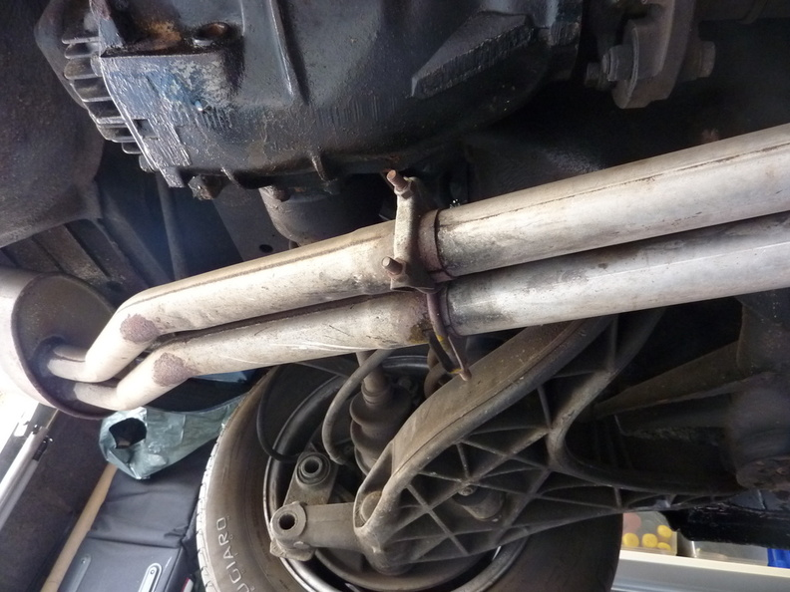
Its likely that the sections will be very difficult to separate unless you have access to oxy acetylene. I hammered off the back section with a chisel and caused some damage to the end of the pipes.
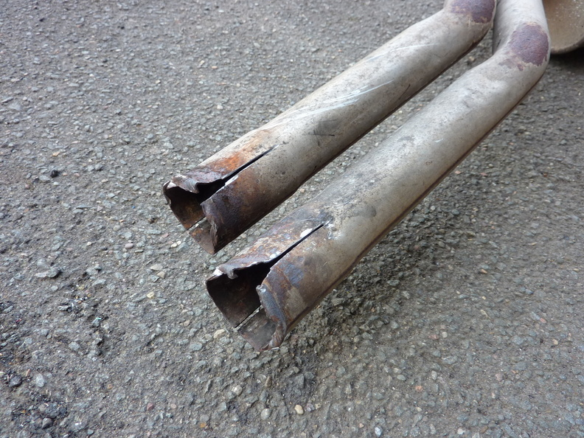

For the middle section I made a diagonal cut with an angle grinder and slitting disc, this allowed removal with less damage. I can then weld up this slot. Note that I wedged the down pipes from below and above, to avoid putting strain on the manifold connection.
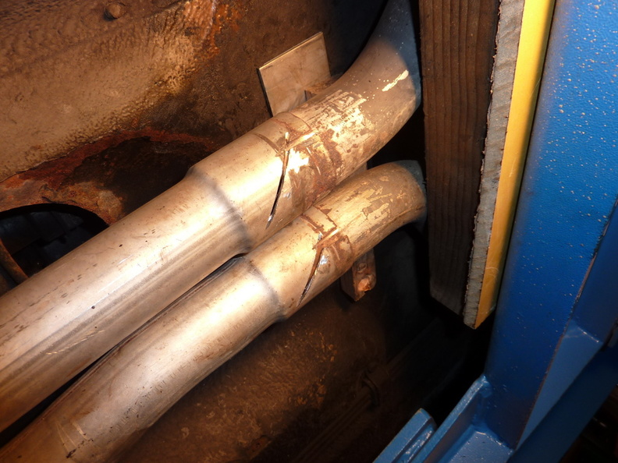
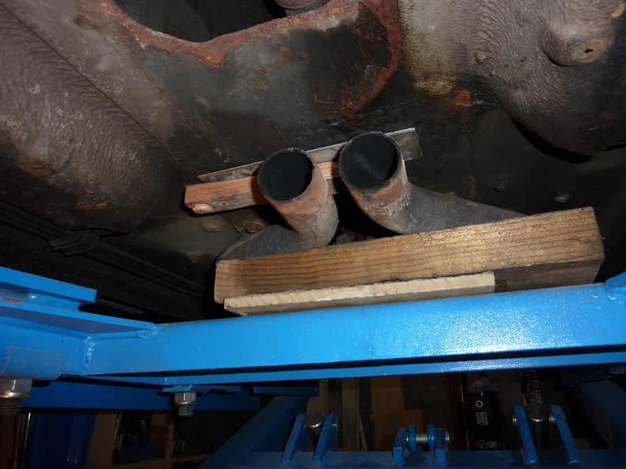

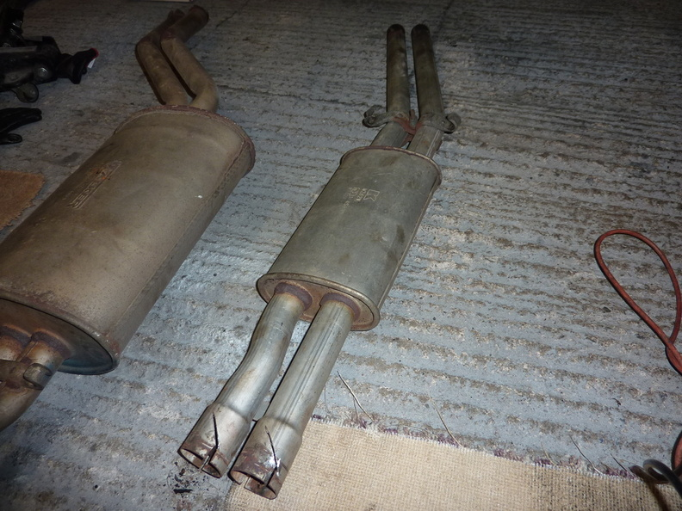

I then lowered the car to the ground and removed the bolts holding the sub-frame brackets to the car body. The reason for this is that I selected this area to support the car on the scissor lift. I chose this area rather than the sills as I plan to do some welding on the jacking point on the sill.
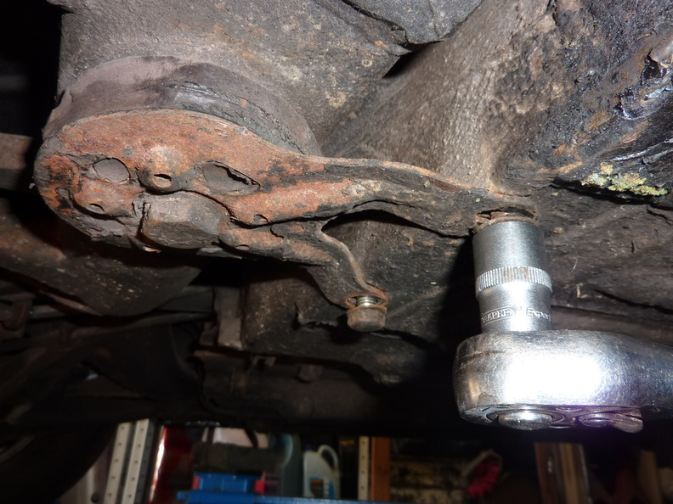
Next I loosened the main sub-frame bolt a ½ turn and pushed the bracket out of the way.
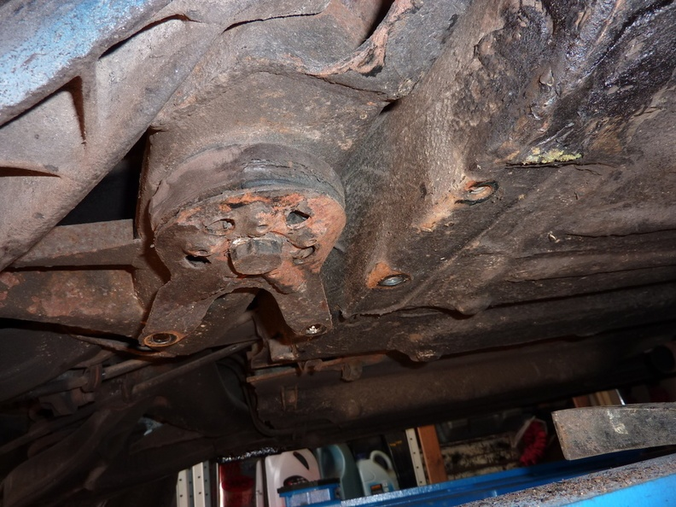
Next I removed the nuts from the top of the shock absorbers, they are located behind the rear seat side panels.
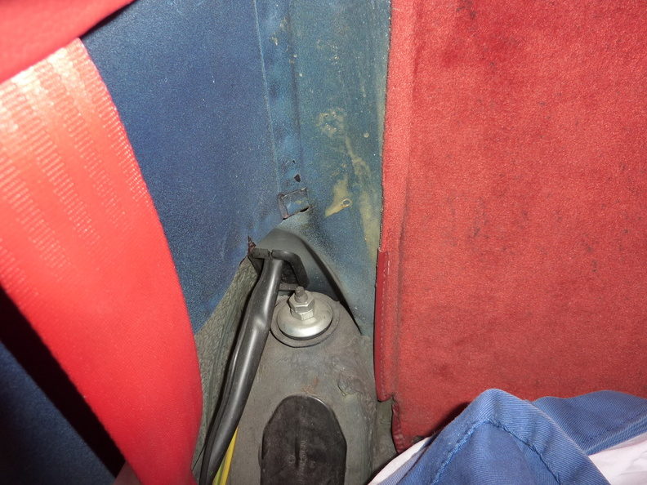
The car was then raised on the lift, I supported the rear here.
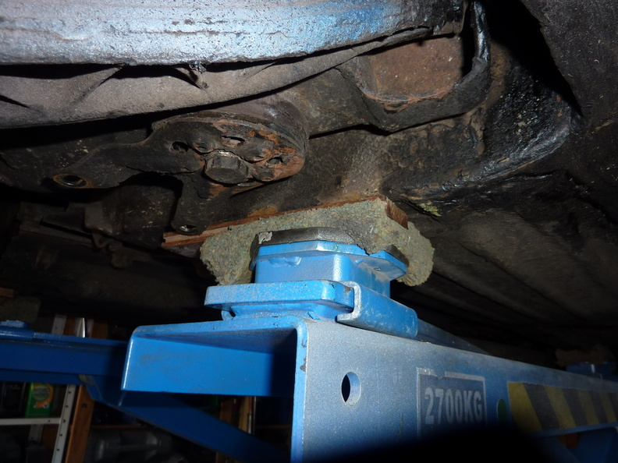
The brake callipers were then removed.
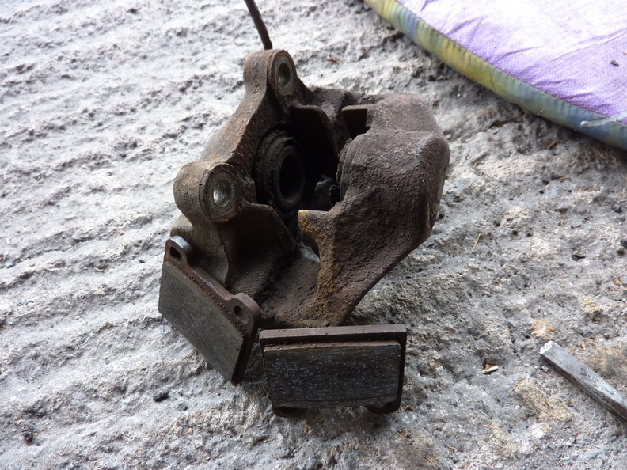
The parking brake should be off and wound back using the adjuster through one of the bolt holes in the hub. The brake disk should then be removed. If it is seized to the hub then a puller may be needed to get it off. I didn’t have a suitable puller so carefully cut a segment out of the disc and used a chisel and hammer to free it from the hub.
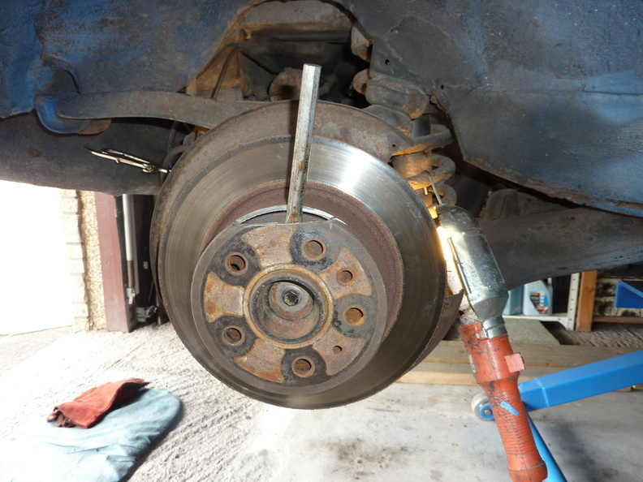
Next I removed the clips holding the hand brake cable in place.
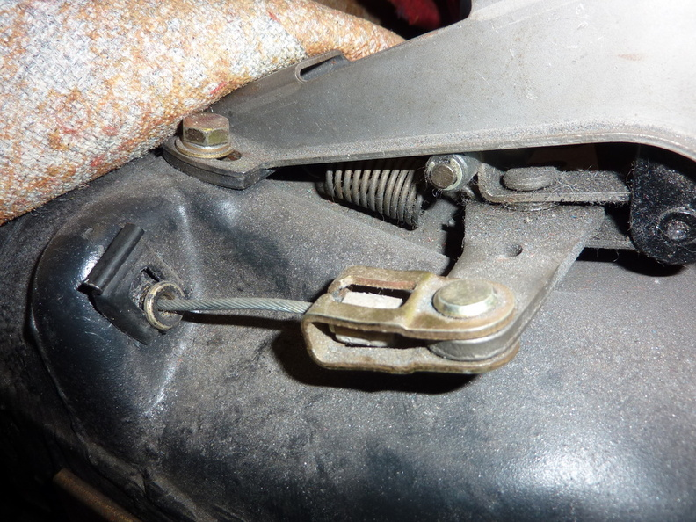
Once the clip is removed the cable can be withdrawn from below, if they are stiff then they can be tapped with a small hammer to be released.
Withdraw the cables out of the transmission tunnel.
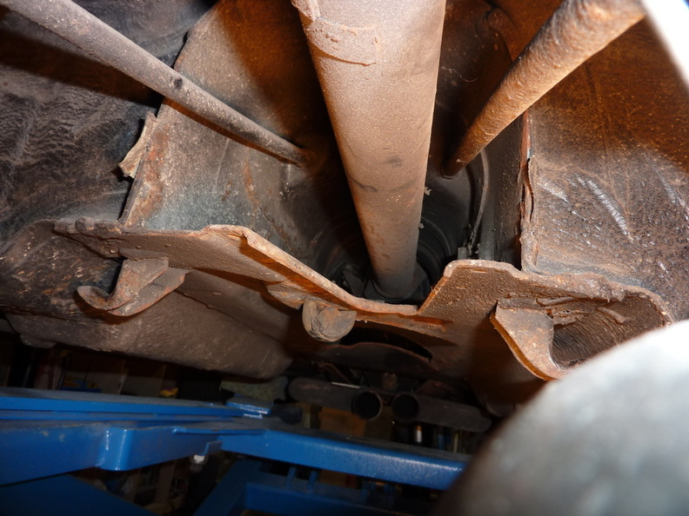
Next remove the “flex plate to diff” bolts.
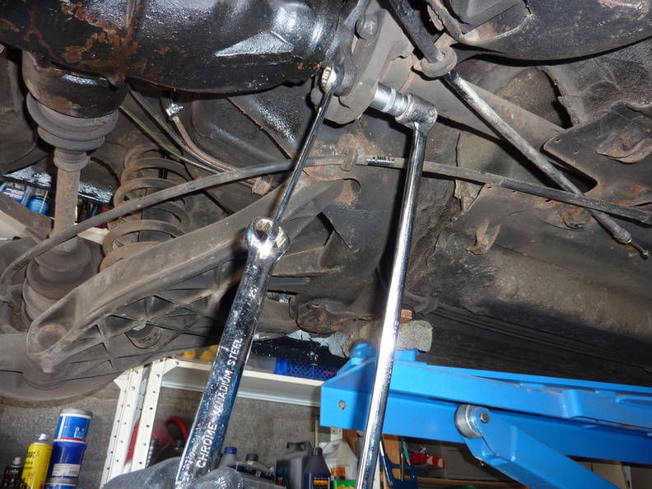
Release the pop shaft pinch bolt and pull back the rubber boot , then mark the splines and front shaft with oil proof paint to aid with reassembly. Also remove the bolts from the prop shaft centre bearing.
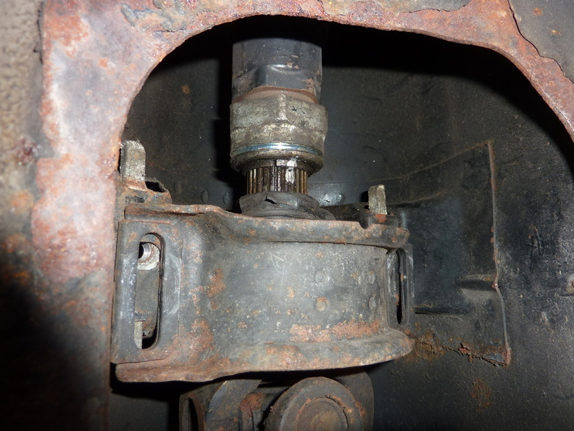
Use a pry bar to force the prop shaft off the diff spigot.
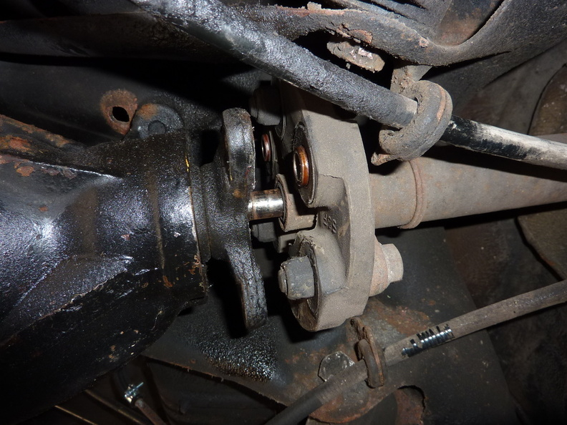

This image shows why the prop shaft need to be remove before the sub-frame can be lowered on this model.
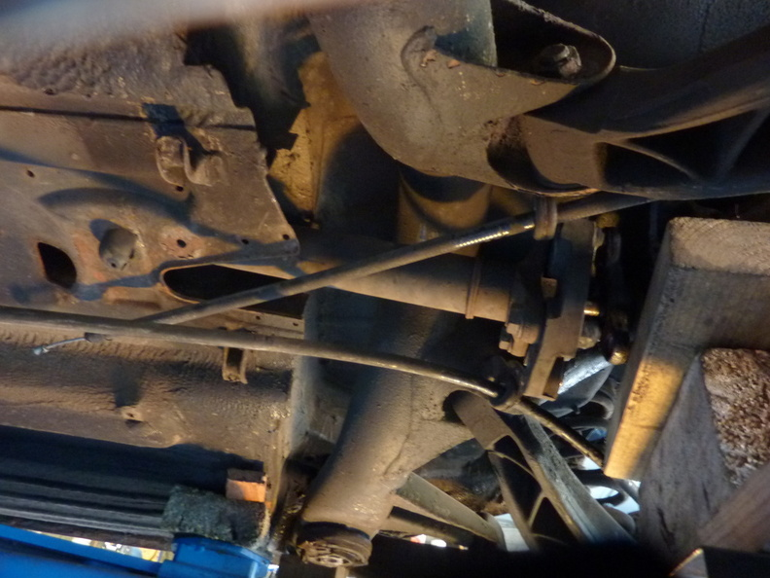
Next, remove the flex disc from the end of the prop shaft, this will make removal easier. You may need to use a pry bar to get it off the end of the prop shaft.
The rear prop shaft can then be withdrawn out of the rear of the vehicle.
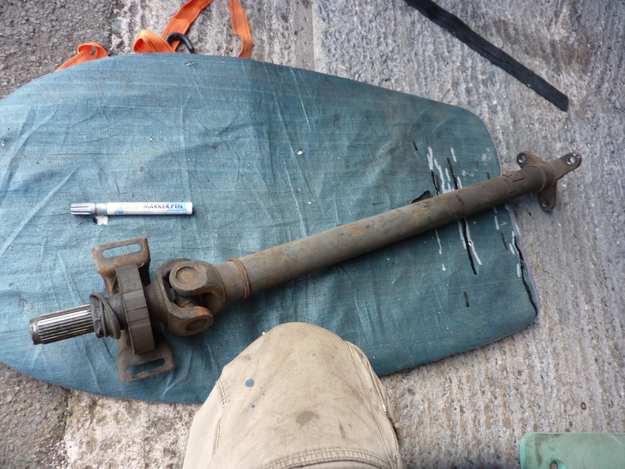
Now is a good time to drain the diff.
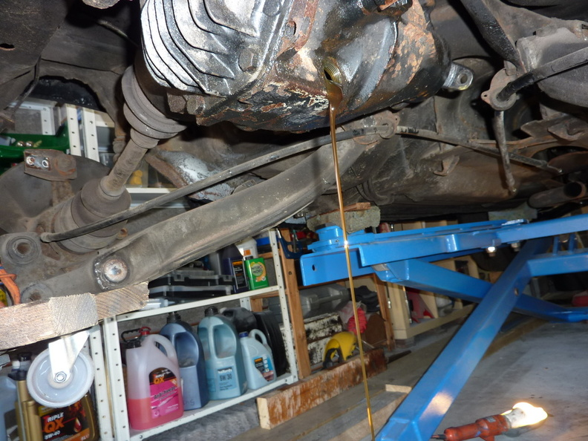

Next, remove the shock absorbers by removing these nuts and withdraw downwards.
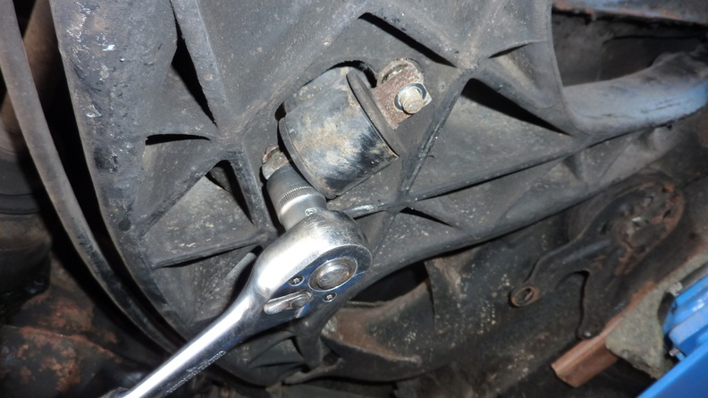
Remove the anti roll bar bush mounts.
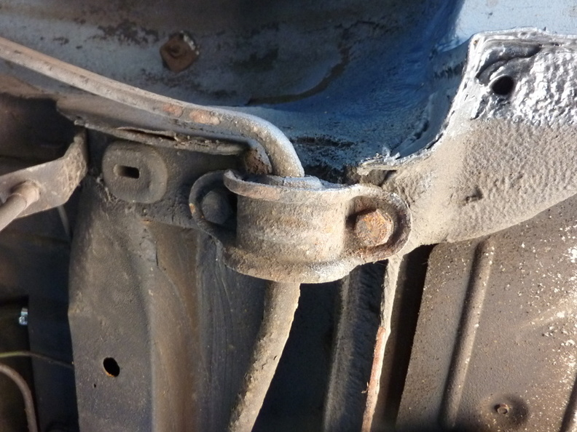

Then release the ends from the hub carrier.
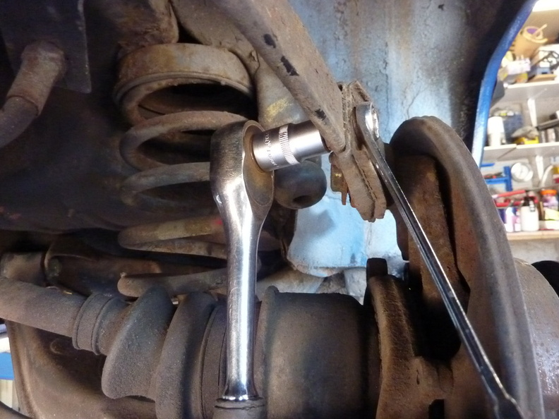
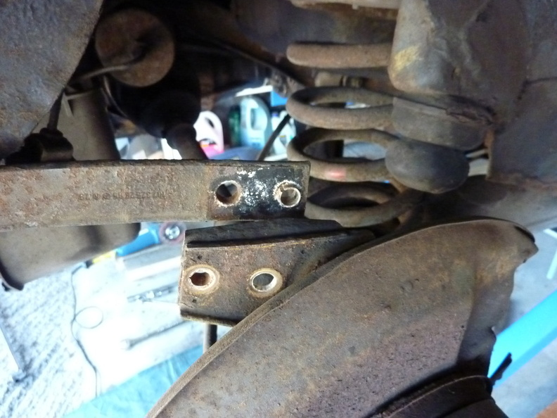

Insert an MB style spring compressor into the spring, capturing 5 rings of the spring and compress.
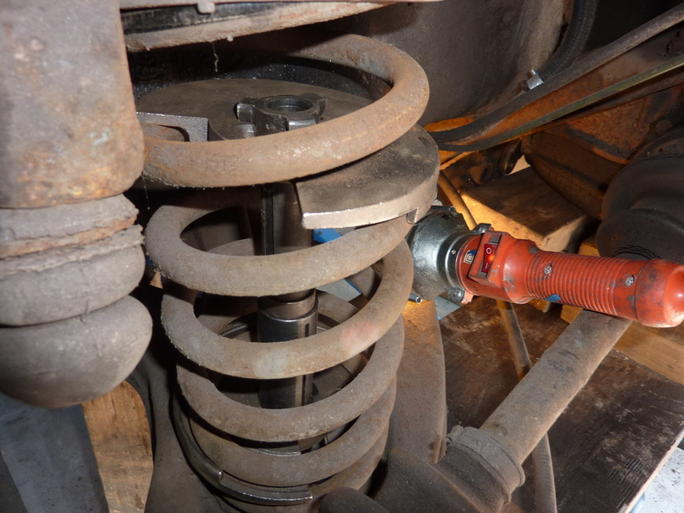
I removed the compressed springs like this.
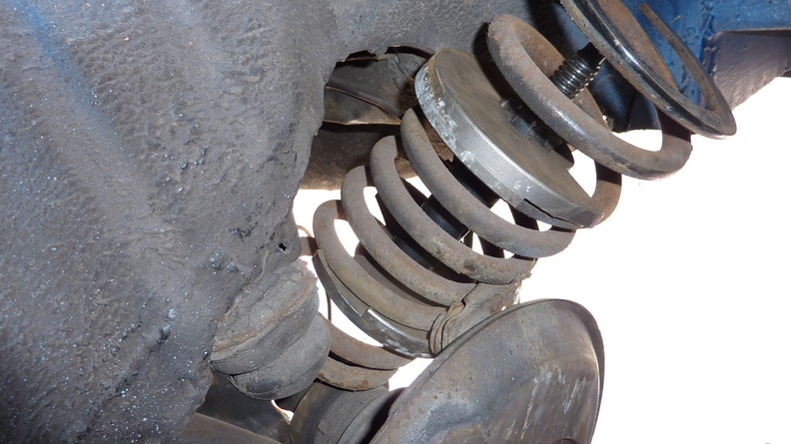

Place a suitable support beneath the diff.
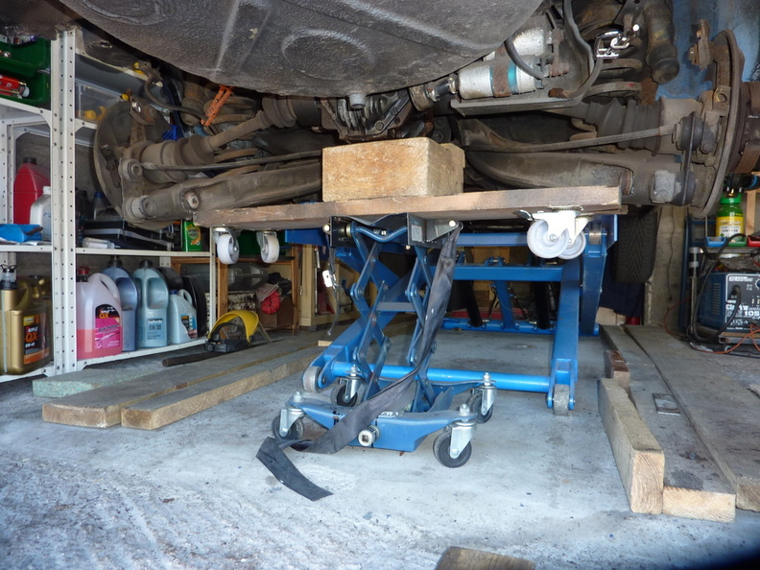
Remove the four bolts that secure the diff hanger support. I suggest using heat on the bolts first as the are known to shear easily. One of mine did.
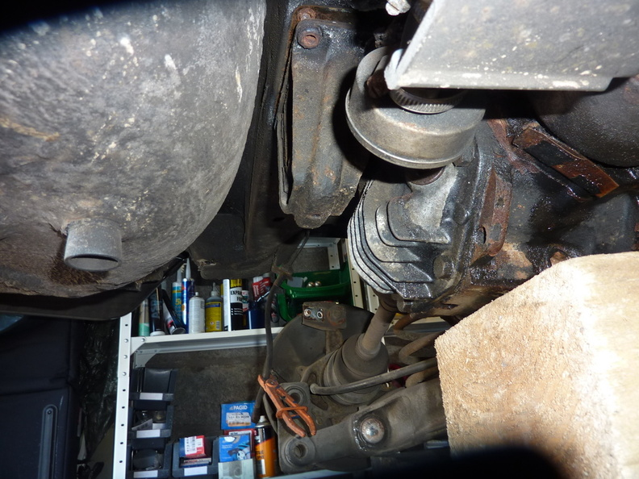
Release the two main sub-frame bush bolts and remove the support brackets.
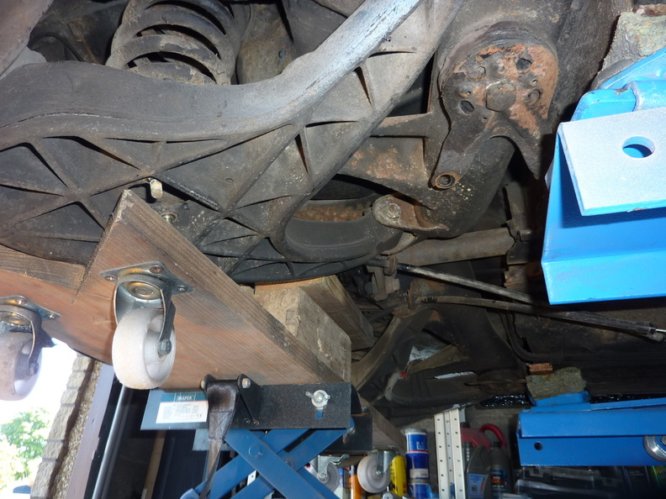
Once the bolts are removed, carefully start to lower the support below the diff. It would be good to have a couple of helpers to steady the sub-frame as it is lowered but I managed it single handed.
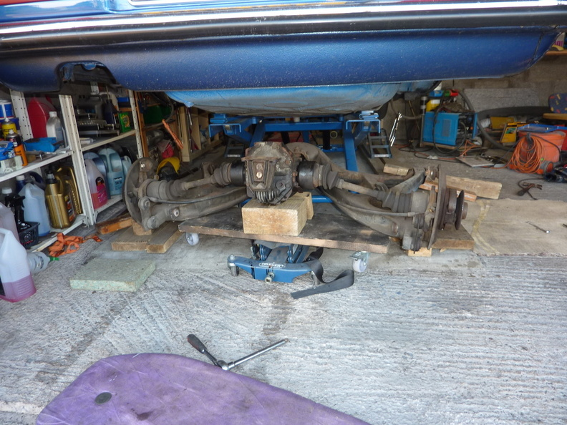

The assembly can then be withdrawn from beneath the car.-
